HR Analytics Project- Understanding the Attrition in HR

- Problem Definition:
Every year a lot of companies hire a number of employees. The companies invest time and money in training those employees, not just this but there are training programs within the companies for their existing employees as well. The aim of these programs is to increase the effectiveness of their employees. But where does HR Analytics fit in this? Is it just about improving the performance of employees?
HR Analytics
Human resource analytics (HR analytics) is an area in the field of analytics that refers to applying analytic processes to the human resource department of an organization in the hope of improving employee performance and therefore getting a better return on investment. HR analytics does not just deal with gathering data on employee efficiency. Instead, it aims to provide insight into each process by gathering data and then using it to make relevant decisions about how to improve these processes.
Attrition in HR
Attrition in human resources refers to the gradual loss of employees overtime. In general, relatively high attrition is problematic for companies. HR professionals often assume a leadership role in designing company compensation programs, work culture, and motivation systems that help the organization retain top employees.
How does Attrition Affect companies? And how does HR Analytics help in analyzing attrition? We will discuss the first question here and for the second question, we will write the code and try to understand the process step by step.
Attrition affecting Companies
A major problem in high employee attrition is its cost to an organization. Job postings, hiring processes, paperwork, and new hire training are some of the common expenses of losing employees and replacing them. Additionally, regular employee turnover prohibits your organization from increasing its collective knowledge base and experience over time. This is especially concerning if your business is customer-facing, as customers often prefer to interact with familiar people. Errors and issues are more likely if you constantly have new workers.
I have to predict the Attrition using machine learning whether it is yes or no.

2. DATA ANALYSIS
I imported the necessary libraries for data cleaning and analysis like pandas,numpy,matplotlib and seaborn.I checked for missing/null values and there were none in the dataset.I explored various statistical information regarding both numerical data type columns and object data type columns.i created the histograms for each of the numerical columns and used pandas groupby functions to derive information from the datasets.I plotted the skewness of the data.

I plotted skewness for all data distributions against columns of the data. plotted green horizontal line for a skewness of zero(normal distribution has a skewness of 0). plotted red lines around the green line denoting a range of(-0.5,0.5). If data points fall within the above mentioned range,then they are approximately normally distributed .
The rule for skewness seems to be: if the skewness is between -0.5 and 0.5, the data are fairly symmetrical. If the skewness is between -1 and -0.5 (negatively skewed) or between 0.5 and 1 (positively skewed), the data are moderately skewed.I also plotted correlation for the numerical columns of the dataset to know the relationship between them.I calculated chi-square test to know the relationship between categorical columns of the dataset.For effective machine learning modelling,removal of excess skewness is necessary.So I used cube root functions and square root functions from numpy library to remove the skewness.However,column 'PERFORMANCE RATING' had skewness even after using numpy functions.I checked the distribution of the target label(the value to predict) and I found that dataset is highly imbalanced meaning the dataset is having more and more counts of 1 class than the other.I used the oversampling technique for the minority class called SMOTE method to balance the dataset.

3.Exploratory Data Analysis(Eda) Concluding Remarks:-
- There Are No Missing Values In The Dataset
- There Are Only 3 Categories For Business Travel,2 For Attrition,3 For Department,6 For Education Field,3 For Marital Status,9 For Job Role,2 For Overtime And 2 For Gender.I Grouped The Datasets By Certain Columns.
- The Mean Age For Attrition ='yes' Is Around 34 And For Attrition='no' Is Higher,Around 37.
- The Average Daily Rate For Attrition ='no' Is Around 812 And For Attrition='yes' Is Around 750.
- 'no' Category Employees Have Higher Daily Rate And Have Served More Years With Current Manager On Average And Also Been In Current Role For More Years Than That Of 'yes' Category On Average.
- 'no' Category Employees Have More Working Years Than 'yes' Category Employees On Average.
- 'yes' Category Employees Have A Higher Monthly Rate Than 'no' Category Employees On Average.
- 'no' Category Employees Have Higher Monthly Income Than 'yes' Category Employees On Average.
- 'yes' Category Has More Distance From Home To Work Than 'no' Category Employees On Average.
- 'no' Category Employees Have More Job Satisfaction And Environment Satisfaction Than 'yes' Category Employees On Average.
- 'no' Category Employees Have Higher Work-life Balance Than 'yes' Category Employees On Average And Also More Relationship Satisfaction On Average.
- There Is Only 1 Unique Element In The ’employee count’ Column Which Is 1.
- I Can Say That In Attrition-->Yes Category, More Employees Have To Work Overtime Whereas In Attrition-->No Category, Lesser Employees Have To Work Overtime.
- I Can Say That In Attrition-->Yes Category, More Percentage Of Employees Are In Human Resources And Sales Department.
- I Can Say That Employees Working In The Sales And Human Resources Department Have A Higher Chance Of Leaving Work(Attrition-->Yes).
- I Can Say That Employees In The Human Resources Department Have A Higher Relationship Satisfaction On Average In Attrition-->Yes Category Than In 'no' Category,Even Though They Left The Company.
- The Employees In Sales Department Had A Higher Monthly Rate On Average In Attrition--> Yes While Those Not Leaving The Company Had A Lower Monthly Rate On Average(Attrition-->No).
- Rest Every Other Factors Like Daily Rate,Environment Satisfaction,Job Satisfaction And Monthly Income Was Better For Employees In Category(Attrition-->No) Than Those In Category(Attrition-->Yes).
- Employees In (Attrition--> Yes) Category Working In Human Resources Department Has Higher Education And Higher Stock Option Level On Average Than Those In (Attrition--> No) Category. It May Be Said That Since They Were Not Not Paid Enough Monthly Income (As Can Be Seen Above),They Left The Company.
- Employees In (Attrition--> Yes) Category Working In Research & Development Department Has Higher Performance Rating And Higher Percent Salary Hike On Average Than Those In (Attrition--> No) Category. It May Be Said That Since They Were Not Not Paid Enough Monthly Income (As Can Be Seen Above),They Left The Company.
- Employees In (Attrition--> Yes) Category Working In Sales Department Had Higher Monthly Rate On Average Than Those In (Attrition--> No) Category. It May Be Said That Since They Were Not Not Paid Enough Monthly Income (As Can Be Seen Above),They Left The Company.
- All The Employees Are Over 18.
- The Top 5 Highest Monthly Income Employees Are In the Research And Development Department.
- I Observed That Employees Having Job Roles As Sales Representative,Laboratory Technician And Human Resources Department Has A Higher Chance Of Leaving Work(Attrition-->Yes).
- I Observed That Employees In Education Field Such As Marketing,Technical Degree And Human Resources Department Has A Higher Chance Of Leaving Work(Attrition-->Yes) Than Other Employees In Other Education Field.
- The Most Number Of Counts For Every Numerical Column Named Is Around:
- 'age'=30
- 'daily_rate'= 400 And 600
- 'Distance from home'=5 And This Distribution Is Rightly Skewed.
- 'education'=3.0
- 'environment satisfaction'=3.0
- 'Hourly rate'=90 And 100.
- 'job involvement'=3.0
- 'job level'=1 And 1.5
- 'job satisfaction'=3.5 And 4.0
- 'monthly income'=2500 Onwards But Less Than 5000
- 'monthly rate'=5000
- 'numcompaniesworked'=0 And 1 And This Distribution Is Rightly Skewed.
- 'percent salary hike'=12 And This Distribution Is Rightly Skewed.
- 'performance rating'=3.0
- 'relationship satisfaction'=3.0
- 'stock option level'=0 And 0.5
- 'Total working years'=10 And 15 And This Distribution Is Rightly Skewed.
- 'training times last year'=2
- 'worklifebalance'=3.0
- 'yearsatcompany'=From 0 Onwards To 5 And This Distribution Is Rightly Skewed.
- 'yearsincurrentrole'= 0 And 2.5 And This Distribution Is Rightly Skewed.
- 'yearssincelastpromotion'= 0 And 3 And This Distribution Is Rightly Skewed.
- 'yearswithcurrmanager'=0 And 3.
- I Observed That Most Number Of Employees Who Did Not Leave The Company Travel Rarely.
- I Observed That Most Number Of Employees Worked In Research And Development Department.
- I Observed That Most Employees Have Life Sciences Education.
- I Observed That Male Employees Have A Higher Chance Of Leaving The Company.
- I Observed That Laboratory Technician Has The Highest Percentage Of Leaving The Company Whereas The Research Director Has The Lowest Percentage Of Leaving The Company.
- From The Data,I Observed That 'Single' Employees Had The Most Percentage Of Leaving The Company And Divorced Employees Had The Least Percentage Of Leaving The Company.
- From The Data,I Observed That Employees Who Worked Overtime Had The Most Percentage Of Leaving The Company.
- There Are Many Columns Having Excess Skewness Like --->Distance From Home,Job Level,Monthly Income,Number Of Companies Worked,Percent Salary Hike,Performance Rating And Stock Option Level,Total Working Hours, Years At Company, Years In Current Role,Years Sincelast Promotion,Years With Current Manager.
- I Calculated Chi-square Test And Made A Matrix Of Each Categorical Column.Below Is The Image Showing Heatmap Of Chi-square Test.
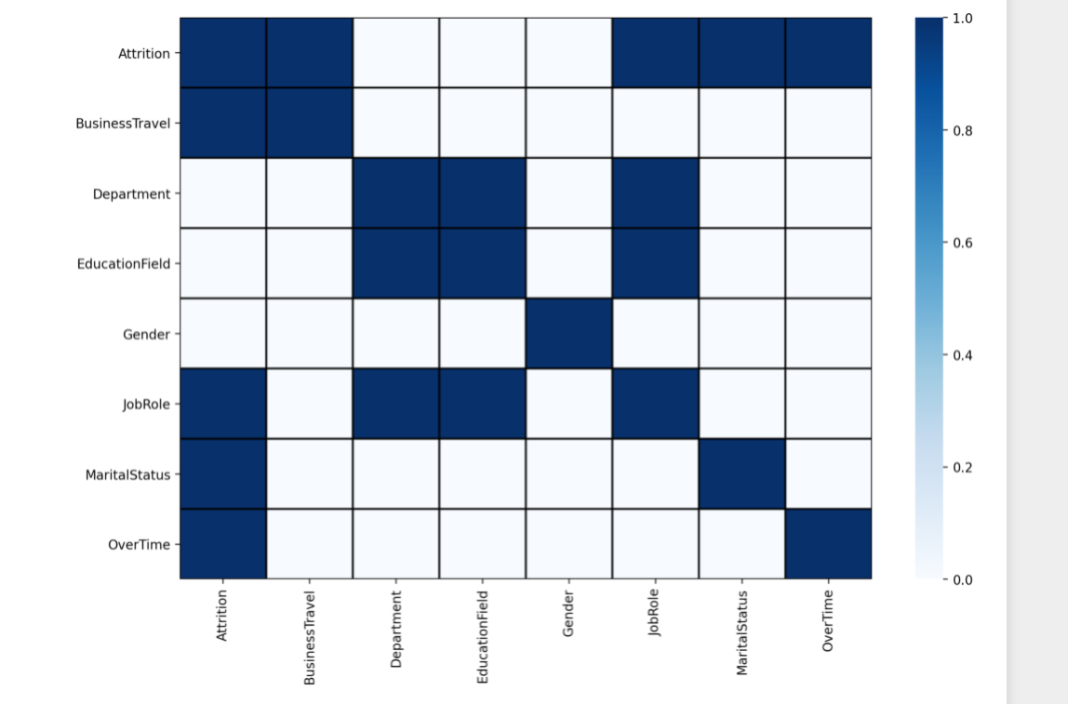

One Can Observe Where There Is Relationship Or Not Based On The Below Statement:-
As Shown In The Above Heatmap Figure,The 'blue' Colour Shows The Relationship Status To Be 'yes' Or (1),Whereas The 'white' Colour Shows The Relationship Status To Be 'no’ Or (0) Between The Variables Of The Dataset.

- I Encoded The Categorical Columns In The Dataset.
- There Are Some Outliers Present In The Dataset.
- I Used Elliptic Envelope Curve Method To Remove My Outliers.Around 5% Of The Data Has Been Removed Because They Have Been Declared Outliers.
- I Removed Excess Skewness For Every Column But ‘Performance Rating’ Skewness Could Not Be Reduced Further.
- I Used The Smote Method To Oversample The Minority Class In Order To Balance The Dataset Between Two Classes.

4.Preprocessing Pipeline
I Imported The Pipeline Object From The Sklearn Library. I Created A Pipeline For Standard Scalar Function And Also For Each Model Used In Fitting And Testing The Data.I Used The Pipeline Along With GridSearchcv To Find The Best Parameters For My Model Based On The Performance Metrics.
5.Building Machine Learning Models
This Is A Classification Task And I Have To Predict The ‘Attrition’(Yes Or No).
I Seperated My Features(X) Data And Target Label(Y) Being ‘attrition’(Yes Or No)’.
I Imported The Necessary Libraries And Metrics For Classification Tasks From Sklearn Library.
I Imported The Models Like-
- Logistic Regression,
- Support Vector Classifier,
- K-nearest Neighbors,
- Decision Tree Classifier,
- Random Forest Classifier,
- Ada Boosting Classifier,
- Gradient Boosting Classifier
- Light Gbm Classifier

I Imported The Performance Metrics And Scores Like-
- Accuracy Score
- Precision Score
- Recall Score
- Classification Report
- Confusion Matrix
- Plot-confusion Matrix
- Auc-roc-curve
- Auc-roc-score
I Did The Train-test Split For The Dataset Using Random State 0 And Test Data Size 30%.The Training Data Was 70% Of The Whole Data And Testing Was 30% Of The Data.For Standardisation And Scaling Purpose,I Imported The Standard Scalar Method From ‘sklearn’ Library.
Only Training Data Has Been Both Fit And Transformed But The Test Data Has Only Been Transformed. '.Fit' Means Calculating Necessary Statistics From The Data And '.Transform' Only Scales The Data. Test Data Should Not Be Fit Because That Would Lead To Assumption Of The Prior Knowledge Of The Test Data And Test Data Is The Data, Machine Learning Model Need To Predict Fairly Without Having Any Knowledge Of The Test Data.
I Used Every Model Imported (As Mentioned Above) For Fitting The Training Data And Then Predicting My Target Variable. I Compared The Performance Of All The Models With Actual Test Data Of Y Using The Metrics And Scores I Imported(As Mentioned Above).
6.Concluding Remarks

After Performing Fitting And Training And Prediction On All The Models,Light Gbm Classifier,Random Forest Classifier,Support Vector Classifier And Gradient Boosting Classifier Were The Best For Their Good Metrics And Scores.They Were Selected For Hyperparameter Tuning Using Grid Search Cv.
I Used A Pipeline For All Those Good Models For Finding The Best Parameters From Grid Search Cv.
After Performing Grid Search Cv With All The Above Selected Best Models,Light Gbm Classifier Has The Best Parameters For The Best Metrics And It Also Performed The Best.
It Has A Higher Auc Score Than Gradient Boosting Classifier.
After Grid Search Cv,I Performed The Randomized Search Cv For The Best Model Light Gbm Classifier To Find The Best Parameters And I Observed That Randomized Search Found Better Parameters Based On The Metrics And Scores.
From Grid Search Cv,Auc-roc Score Was Approximately 93% But From Randomized Searchcv, Auc-roc Score Was Higher(93.27%).
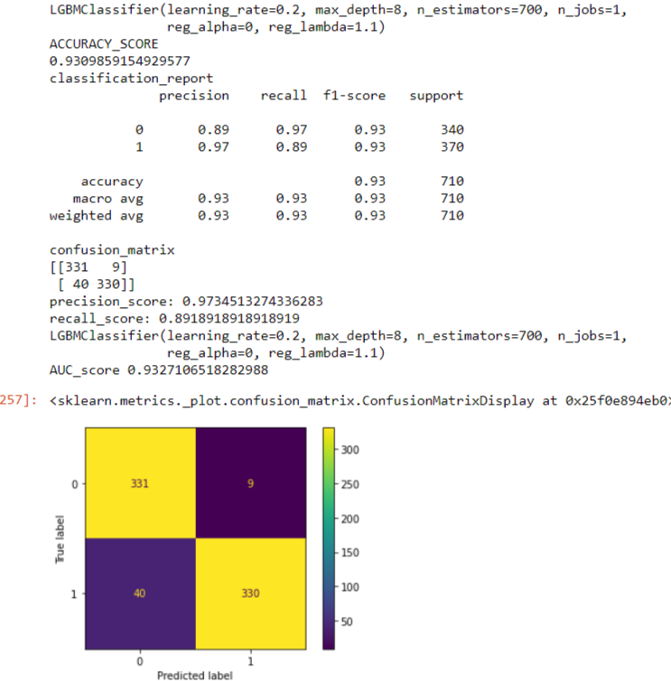
I Created A Light Gbm Classifier Model From The Best Parameters Found In Randomized Search Cv.
I Imported Joblib Library To Save The Model And Dump It.

